My soul has no gender: it has constantly changing amounts of male and female energy. This is true for plants and animals as well. Everything we are and everything around us is energy. Our souls exist even after we die, energy never ceases to exist, and it is infinite.

Therefore, is the “issue” of homosexuality a physical, earthly issue?

Recently, in an ancient grave in the Czech Republic, archaeologists have found the remains of what they believe to be the first known remains of a gay or transvestite caveman[1]. How do they know? This ancient culture, like most others, had very strict burial rites, and this man was buried as if he were a woman. It is very unlikely that this was a mistake. Despite their strict rites and beliefs they were accepting this person as he was or felt to be, and did not impose on him a specific life he was not born to live. Considering the fact that the grave dates between 2500 and 2300BC yet the first books of the Bible was only written by Moses between 1500 and 1300 BC, one can see that it must be religion that then made up this “issue”. A grave from the Mesolithic Period also revealed a female warrior was buried as a man. Ancient cultures did not have religion such as Christianity and Islam, but they were spiritual and explained their world through what they observed in natures. Many believe in spirits.

Let’s look at the Bible’s so called Clobber Passages – those used to condemn homosexuality.

According to Reverend Doctor Walter Wink[2], and other scholars[3], Gen 19:1-29 describes the  
”attempted gang rape in Sodom. This referred to seemingly heterosexual males intent on humiliating strangers by treating them “like women” and demasculinising them”. A similar account is described in Judges 19-21. Both these accounts speaks more about the behaviour of the citizens that violated the norms of conduct of hospitality, including rape and abuse, and the hosts offered their own daughters to protect strangers from being victimised (an aversive act in itself), homosexuality is therefore not the issue here. Likewise, this brutal behaviour has nothing to do with whether genuine love expressed between same-sex, consenting adults is legitimate or not. Rape should not be condoned whether heterosexual or homosexual. Also, *all* of the men in Sodom were involved here, and it is very unlikely that all of them were homosexual.

Deut.23:17-18 also most likely refers to heterosexual prostitutes involved in Canaanite fertility rites that have infiltrated Jewish worship. The original Hebrew word is interpreted as referring to ritual prostitution which was, throughout the Bible, said to be prominent at religious shrines. However, Greenspahn notes that the references do not refer to specific activity and homosexuality, it could well have been heterosexual prostitution or not be related to sexual activity at all

The problem with 1 Cor. 6:9 and 1 Tim. 1:10 lies in the translation of two terms. Corinthians Paul is attacking practices he has heard of that occur in the Corinthian churches, and none of them have anything to do with homosexuality. In Timothy the translations from Greek were incorrectly interpreted within the context of the passages.

The three remaining texts unequivocally condemn homosexual behaviour. Lev. 18:22, Lev 20:13 and Rom. 1:26-27. However...during the time it was written, the Hebrew understanding was that male semen contained the whole of embryonic life, no eggs and ovulation. The woman was only an incubator. In this context, according to Christianity, God had a plan that the Messiah had to be born and therefore sex for non-procreative purposes would defeat this purpose. Slick[4] states then that “if homosexuality was to run rampant, it would threaten the arrival of the Messiah and thereby make God’s Word invalid (essentially making God a liar), and this cannot be.” Let’s think about this for a moment: I seriously doubt that *all* men were homosexual, and therefore, it would never be rampant. Secondly, Jesus was born to the *virgin Mary*, therefore, sex was not necessary at all! (if you believe in the Bible). Thirdly, God is God, who apparently has a plan and can make anything happen. If his prophecy was threatened, he could’ve made anyone else pregnant as well.

If sex for non-procreative purposes was wrong, sex for pleasure between a man and women (even if married) should also be wrong as thereis no inent to procreate at the time. Therefore, it does not apply to consenting adults having sex whether within a marriage or not and whether homosexual or not. If you base your beliefs on the Old Testament, one must demand death penalty for homosexual acts. Many of the other rules in Leviticus were however ridiculous, such as no sex with a women who is menstruating. It is puzzling though that those using these passages choose to condemn homosexuality but they do not apply the other ones to modern life. So they are selective in which rules they choose to apply and which not.

That is why we have the New TestamentThe New Testament cancels the Rules in Leviticus in the Old Testament. Writing Romanians (Rom. 1:26-27) Paul was not aware of a distinction between sexual orientation (born that way) and sexual behaviour (choose). Paul really thought those whose behaviour he condemned were” straight” and they were behaving unnaturally for *them.* Research has proven that homosexual behaviour (sexual activity, courtship, affection, pair-bonding and parenting) manifests itself in a wide variety of species from primates to gut worms[5], thus, is it really unnatural?

These passages, as well as many people who claim homosexuality is wrong, never speak to love and passion. It does not comment on a loving, honest relationship between two people. Whatever you do in your privacy has nothing to do with other people, they have their own issues. We must also add that you may not judge, and telling a person it is a sin to be gay, is a judgement you are not allowed to make.

In a recent social experiment a guy asked people on the streets if they think gay people are born that way or nurtured and/or a choice. Most said it was a choice. He then asked them: “when did you choose to be straight?” This made them think, because they were born that way, and therefore gays were also born that way.

Research has proven the existence of genes that predispose men (the study was based on 400 gay men only) to be homosexual[6]. Several genes determine this. There are many studies done on this since the 1990s although environmental factors also play a role in conjunction with these genes.

It is clear, that religion cannot be used as an authority on whether homosexuality is wrong/sinful or not as it were merely comments of observations by the authors of the books of the Bible. Interpretation differs significantly between different churches and versions of Bibles. It is much more natural than people are made to believe.

Parents with children who are gay (and parents in general) must also consider the fact that they are supposed to unconditionally love their children, no matter what. This is also part of the major message of “God”. To disown them because of this is more unnatural than homosexuality.

I leave you with reply from a grandfather to his daughter who disowned her son (his grandson) for being gay. Perspective.

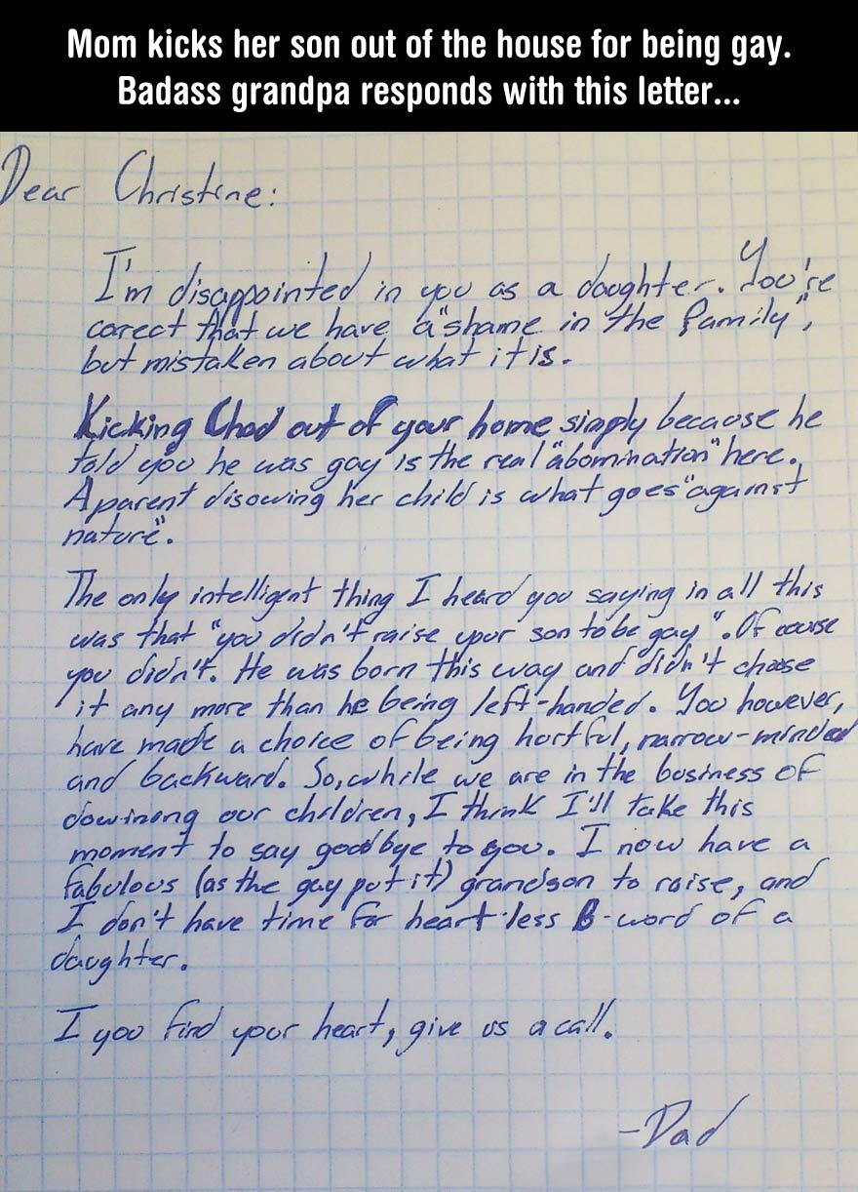

1. http://www.telegraph.co.uk/news/newstopics/howaboutthat/8433527/First-homosexual-caveman-found.html
2. Wink, W. Homsexuality and the Bible.
3. Greenspahn, FE & Witt, C. Homosexuality and the Bible.
4. Matt Slick. Leviticus 18:22, 20:13, and “a man who lies with a man”
5. http://en.wikipedia.org/wiki/Homosexual_behavior_in_animals
6. http://www.theguardian.com/science/2014/feb/14/genes-influence-male-sexual-orientation-study